Instructions Lab 8

You are to do the walkthrough exercises in the Lab 8 PDF and then complete Project 3 in Chapter 6 (page 281-2).

Rather than provide the starting files on Blackboard or on NetStorage, the files for lab 8 (and also for assignment #1) are available on GitHub. You will have to do ~~an impossibly hard and grueling amount~~ a little bit of learning on your own to get up to speed on **Git** and **GitHub**. I’ve found the following online resources helpful:

<http://rogerdudler.github.io/git-guide/>

<http://readwrite.com/2013/09/30/understanding-github-a-journey-for-beginners-part-1>

<https://www.youtube.com/watch?v=8oRjP8yj2Wo&index=1&list=PLg7s6cbtAD165JTRsXh8ofwRw0PqUnkVH>

**Git** is version control software and will need to be installed locally on your development computer. It is old-school, command line software that looks like it belongs right out of the 1980s, but that seems to be the fashion nowadays for programmers. When you are working by yourself, version control software might not seem that useful. But when you work in a team environment (like you will be doing in this course), it is essential. Yet, even if you lose all your friends and colleagues and decide to only program by oneself, version control software is still useful. Why? Because it allows you to track changes to any of your code and potentially revert back to previous working versions.

**GitHub** provides a remote web-based place to store the files in your Git project. In Git-lingo, it hosts your Git repositories, and allows collaborators to push and pull changes. GitHub is free to use for public repositories (i.e., available to anyone). It costs additional money for private repositories. There are other web-based Git hosting services: BitBucket is probably the most popular alternative.

Eventually (but not necessarily right now for this lab) you are going to need to do the following things:

1. Download and install Git for your operating system
2. Config Git for your computer
3. Create your own account on GitHub.

You can find the files for Lab 8 at:   
https://github.com/rconnolly/comp4513-lab08

If you navigate to this URL, you will see an option to download the project contents (called a repository in Git) as a ZIP file. That is one option that requires no knowledge about Git.

Another option is to clone the repository directly within Cloud9. For this you will need the Git repository name (it is a URL ending in a .git extension), which can be found (and copied) in GitHub (see arrow below).

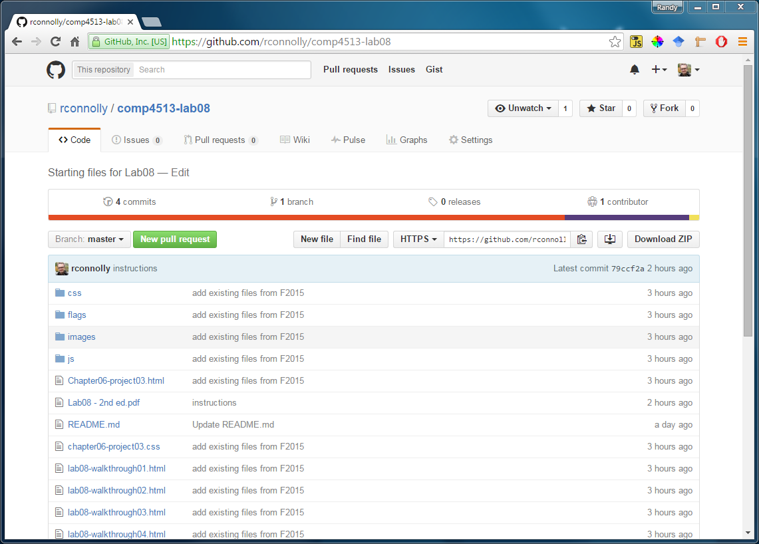

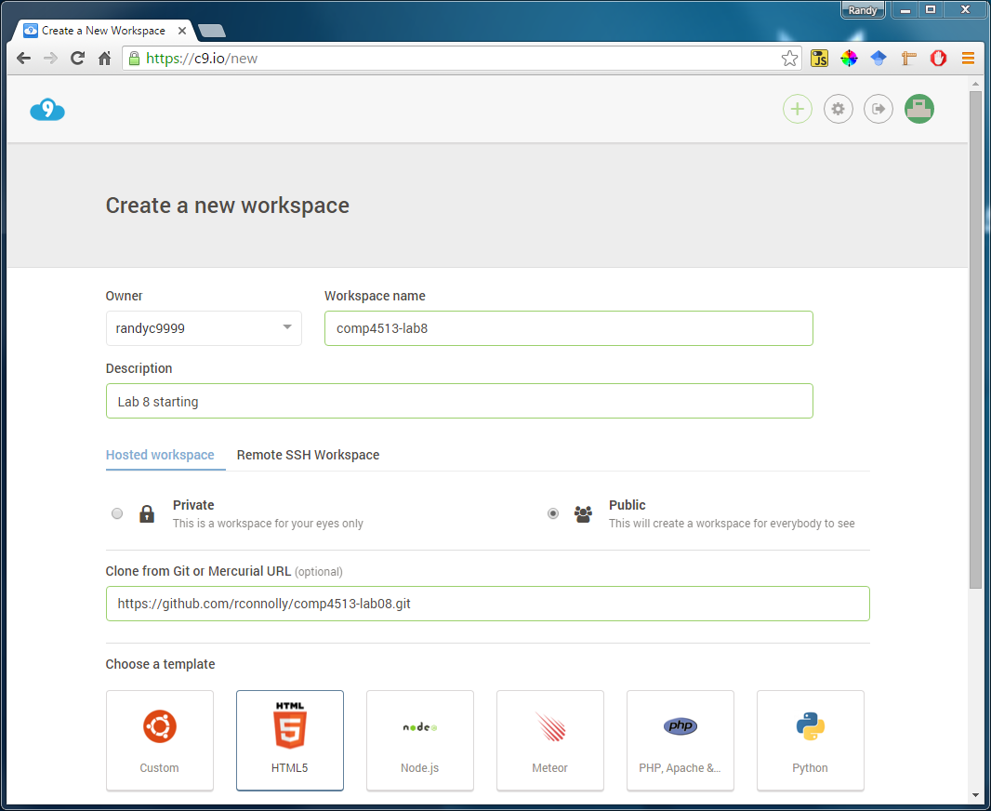Once you have the repository URL, you can enter or paste it when creating a new workspace in Cloud9 (see arrow below):

This will clone the files and add them to the Cloud9 workspace (see below). You could then complete the lab within cloud9 or download the project onto your local computer.

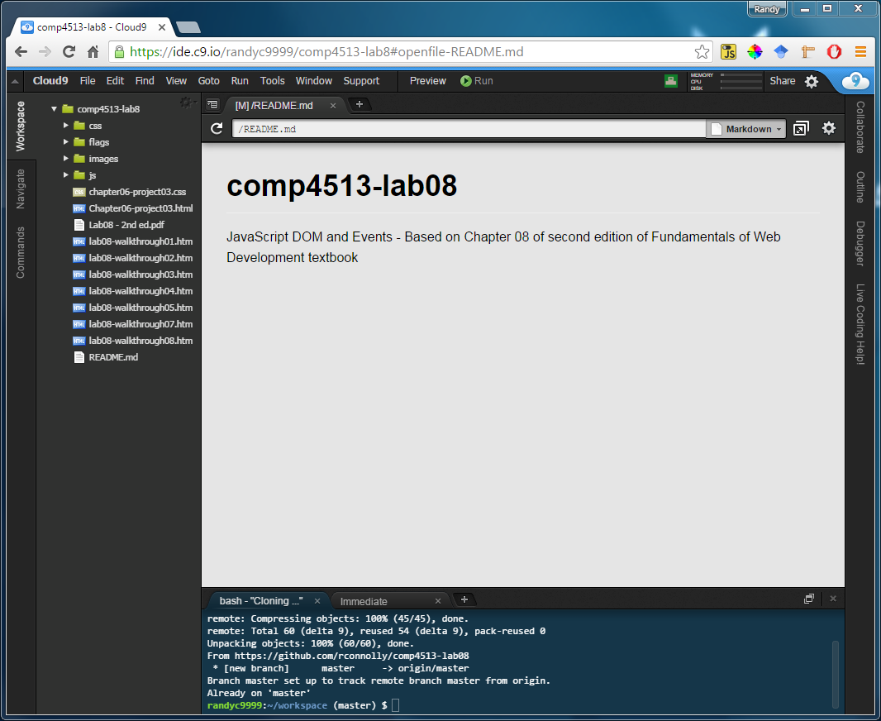

Alternately, you can skip Cloud9 and use Git on the command line of your local computer to get the files. In this case, you would do the following steps/commands (I’m assuming you’ve already configured your copy of Git):

1. Using the terminal (in Mac) or CMD (or PowerShell) in Windows, navigate to the folder that will contain the lab 8 files.
2. Initialize the folder as a Git folder via:   
   git init
3. Clone the remote repository via:   
   git clone https://github.com/rconnolly/comp4513-lab08.git
4. Start working / coding. We will learn more sophisticated approaches such as forking later in the course.

Please do not push your code back to my public repository!

You can find the GitHub repository for Assign 1 at:

https://github.com/rconnolly/comp4513-assign1